**World Quant University**

**Professor: Ivan Blanco**

**Alpha Design I**

Nikolas Lippmann Pareschi - [nikolaslippmann@gmail.com](mailto:nikolaslippmann@gmail.com)

**Mini Project: Unit 6**

**Part 1**

Consider a mutual fund with beta of 0.8 which has an expected rate of return of 14%. If risk-free rate of return is rf = 5%, and you expect the rate of return on market portfolio to be 15%.

Use Python to address the following questions:

1. Would you be interested in investing in the fund? If so, what is the Alpha of the fund.
2. What passive portfolio comprised of a market-index portfolio and a money-market account would have the same beta as the fund?

Note: show that the difference between the expected rate of return on this passive portfolio and that of the fund equals the alpha from question 1.

Code:

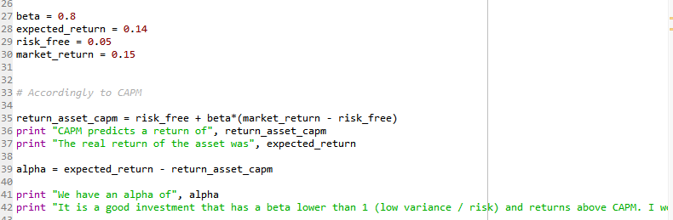



As answered in the Python arquive, the investment has a positive alpha of 1% accordingly to CAPM. It has a good risk reward profile, considering that one could short sell other securities, be market neutral and yet profit going long in this security.

Answering question 2:

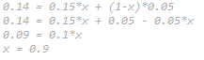

We could have 90% of the money applied to the overall market and 10% of the money applied to the risk free investment to achieve beta of the considered investment.

**Part 2**

Consider the following data for a one-factor economy. All portfolios are assumed to be well diversified.

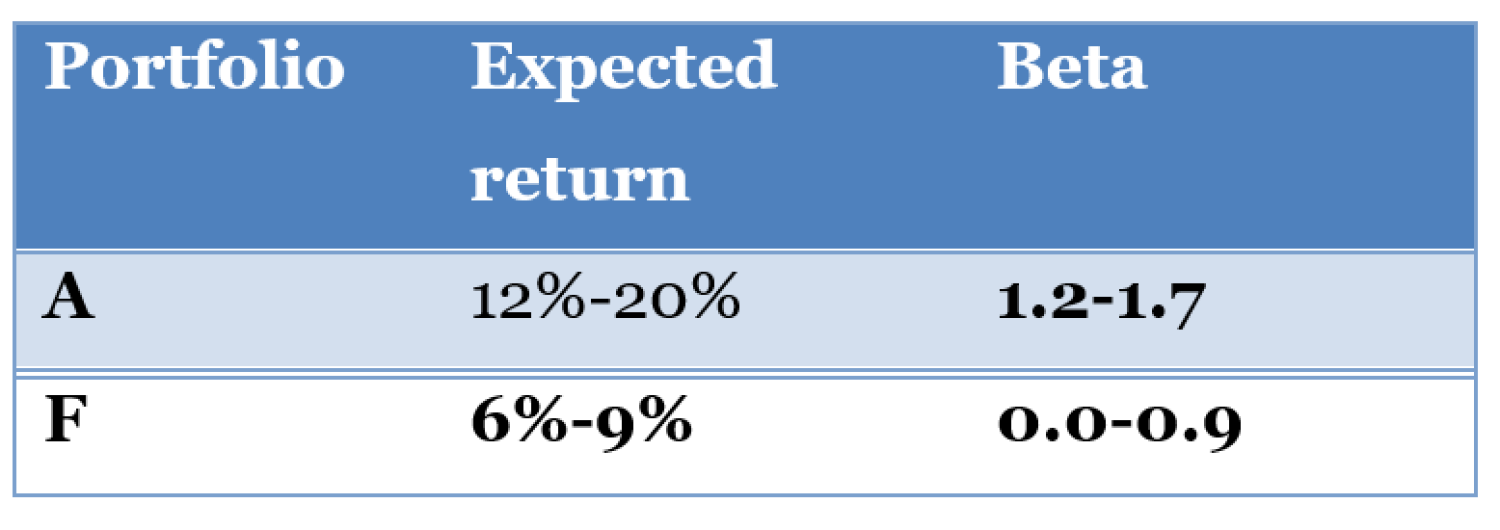

**Note**: Consider that Expected Return changes in step sizes of 1% (e.g. Portfolio A can have expected returns of 12%,13%,…19%,20%) and Beta change in step sizes of 0.1 (e.g Portfolio F can have Beta values of 0.0,0.1,0.2,….0.8,0.9)

Suppose that another portfolio, portfolio E, is well diversified with a beta of 0.6 and expected return of 8%.

1. For which range of values of Expected Return and Beta would an arbitrage opportunity exist?
2. Develop a simple strategy in Python to exploit the most of the juice out of the arbitrage opportunity strategy for each of the cases
3. Plot the risk-reward profiles of these strategies (for each set of combination of Expected Return and Beta for Portfolio A & F) and discuss.

Considering Portfolio A and assuming the linear relationship of CAPM we will have that:

12% = RFa + 1,2(MRa – Rfa)

20% = RFa + 1,7(MRa – Rfa)

These CAPM equations gives us the value of:

MRa = 8,8%

RFa = - 7,2%

Considering Portfolio B and assuming the linear relationship of CAPM we will have that:

6% = RFb + 0*(MRb – RFb)

9% = RFb + 0,9(MRb – RFb)

RFb = 6%

MRb = 9,333%

As RFb > RFa and MRb > MRa we will have an arbitrage opportunity of shorting Portfolio A and going long Porfolio B. One should only be careful to be market neutral. We have different proxies from risf free rates and for overall market returns. Actually we do no even need to enter into the market, we can make an arbitrage in the risk free rates as well because they are different. If we have different risk free rates we will have arbitrage opportunities going short (borrowing) the lower return environment and going long (leveraging) the higher return environment.

Below we have the returns of our portfolios accordingly to the betas>

